

St Cuthbert’s RC Academy Trust Charging and Remissions Policy

St Mary Queen of Martyrs VC Academy
2025/26
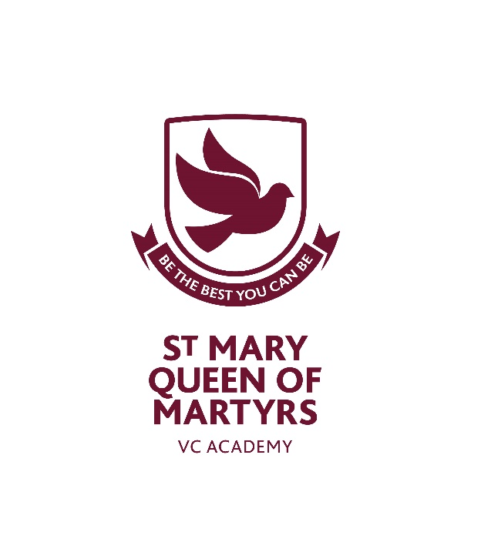
Approved by: | Finance Audit and Capital Assets | Date: July 2025
Last reviewed on: | July 2025
Next review due by: | September 2026

Contents
1. Aims 2
2. Legislation and guidance 2
3. Definitions 2
4. Roles and responsibilities 2
5. Where charges cannot be made 3
6. Where charges can be made 4
7. Voluntary contributions 5
8. Activities we charge for 5
9. Remissions 6
10. Monitoring arrangements 7

1. Aims
Our Trust aims to:
- Have robust, clear processes in place for charging and remissions
- Clearly set out the types of activity that can be charged for and when charges will be made

2. Legislation and guidance
This policy is based on advice from the Department for Education (DfE) on charging for school activities and the Education Act 1996, sections 449-462 of which set out the law on charging for school activities in England. Academies are required to comply with this Act through their funding agreements.
This policy complies with our funding agreement and articles of association.

3. Definitions
- Charge: a fee payable for specifically defined activities
- Remission: the cancellation of a charge which would normally be payable

4. Roles and responsibilities
4.1 The Trust Board
The Trust Board has overall responsibility for approving the charging and remissions policy, but can delegate this to a committee, an individual governor or the headteacher.
The Trust Board also has overall responsibility for monitoring the implementation of this policy.
Responsibility for approving the charging and remissions policy has been delegated to the Finance, Audit and Capital Assets Committee.
Monitoring the implementation of this policy has been delegated to the Finance, Audit and Capital Assets Committee.

4.2 Chief Financial Officer
The CFO is responsible for ensuring staff are familiar with the charging and remissions policy, and that it is being applied consistently.
4.3 Staff
Staff are responsible for:
- Implementing the charging and remissions policy consistently
- Notifying the CFO of any specific circumstances which they are unsure about or where they are not certain if the policy applies
The Business Support Team will provide staff with appropriate training in relation to this policy and its implementation.
4.4 Parents
Parents are expected to notify staff or the CFO of any concerns or queries regarding the charging and remissions policy.

5. Where charges cannot be made
Below we set out what we cannot charge for:
5.1 Education
- Admission applications
- Education provided during school hours (including the supply of any materials, books, instruments or other equipment)
- Education provided outside school hours if it is part of:
- The national curriculum
- A syllabus for a prescribed public examination that the pupil is being prepared for at the school
- Religious education
- Entry for a prescribed public examination if the pupil has been prepared for it at the school
- Examination re-sit(s) if the pupil is being prepared for the re-sit(s) at the school
5.2 Transport
- Transporting registered pupils to or from the school premises, where the local authority has a statutory obligation to provide transport
- Transporting registered pupils to other premises where the Trust Board or local authority has arranged for pupils to be educated
5.3 Residential visits
- Education provided on any visit that takes place during school hours
- Education provided on any visit that takes place outside school hours if it is part of:
- The national curriculum
- A syllabus for a prescribed public examination that the pupil is being prepared for at the school
- Religious education
- Supply teachers to cover for those teachers who are absent from school accompanying pupils on a residential visit

5.4 Nursery Provision
- Early Education entitlements funded by the government are provided completely free of charge. No top-up fees are applied.

6. Where charges can be made
Below we set out what we can charge for:
6.1 Education
- Any materials, books, instruments or equipment, where the child’s parent wishes him or her to own them
- Optional extras (see section 6.2)
- Music and vocal tuition, in limited circumstances (see section 6.3)
- Nursery provision that extends beyond the element of entitlement funded by the government
- Community facilities
- Examination re-sit(s) if the pupil is being prepared for the re-sit(s) at the school and the pupil fails, without good reason, to meet any examination requirement for a syllabus
6.2 Optional extras
We are able to charge for activities known as ‘optional extras’. In these cases, schools can charge for providing materials, books, instruments or equipment. The following are optional extras:
- Education provided outside of school time that is not part of:
- The national curriculum
- A syllabus for a prescribed public examination that the pupil is being prepared for at the school
- Religious education
- Examination entry fee(s) if the registered pupil has not been prepared for the examination(s) at the school
- Transport (other than transport that is required to take the pupil to school or to other premises where the local authority or Trust Board has arranged for the pupil to be provided with education)
- Board and lodging for a pupil on a residential visit
- Extended day services offered to pupils (such as breakfast clubs, after-school clubs, tea and supervised homework sessions)
When calculating the cost of optional extras, an amount may be included in relation to:
- Any materials, books, instruments or equipment provided in connection with the optional extra
- The cost of buildings and accommodation
- Non-teaching staff
- Teaching staff engaged under contracts for services purely to provide an optional extra (including supply teachers engaged specifically to provide the optional extra)
- The cost, or an appropriate proportion of the costs, for teaching staff employed to provide tuition in playing a musical instrument, or vocal tuition, where the tuition is an optional extra
Any charge made in respect of individual pupils will not be greater than the actual cost of providing the optional extra activity, divided equally by the number of pupils participating.
Any charge will not include an element of subsidy for any other pupils who wish to take part in the activity but whose parents are unwilling or unable to pay the full charge.
In cases where a small proportion of the activity takes place during school hours, the charge cannot include the cost of alternative provision for those pupils who do not wish to participate.
Parental agreement is necessary for the provision of an optional extra which is to be charged for.
6.3 Music tuition
Schools can charge for vocal or instrumental tuition provided either individually or to groups of pupils, provided that the tuition is provided at the request of the pupil’s parent.
Charges may not exceed the cost of the provision, including the cost of the staff giving the tuition.
Charges cannot be made:
- If the teaching is an essential part of the national curriculum
- If the teaching is provided under the first access to the Key Stage 2 instrumental and vocal tuition programme
- For a pupil who is looked after by a local authority
6.4 Residential visits
We can charge for board and lodging on residential visits, but the charge must not exceed the actual cost.

7. Voluntary contributions
As an exception to the requirements set out in section 5 of this policy, the school can ask for voluntary contributions from parents to fund activities during school hours which would not otherwise be possible.
Some activities for which the school may ask parents for voluntary contributions include school visit or trip, sporting activity etc.
There is no obligation for parents to make any contribution, and no child will be excluded from an activity if their parents are unwilling or unable to pay.
If the school is unable to raise enough funds for an activity or visit, then the activity will be cancelled.

8. Activities we charge for
The school will charge for the following activities or materials:
St Mary Queen of Martyrs VC Academy charges for:
Some enrichment school trips that are not essential to the curriculum and therefore fall outside the scope of voluntary contributions.
School trips.
Nursery sessions that extend beyond the element of entitlement funded by the government.
Some materials used in subjects like Food Technology and special projects.
Some additional textbooks such as revision aids.
Musical instrument tuition (including singing).
Optional extras.
School meals.
Wrap Around Care
Activities not run by the school.
Breakages and fines if they result from pupils’ misbehaviour.
Recovery of charges.
Staff private photocopying. This is not encouraged but the cost of private photocopying will be passed on to the staff member if exceptionally agreed.
School uniform.
Lost reading books.
Charges are calculated as follows:
- Trips are calculated by taking the total sum of transport, entrance fees plus any associated costs and dividing by number of pupils taking part in the trip.
- Residential trips are calculated by taking the total sum of transport, board and lodgings divided by number of pupils going on the residential.
- Nursery charges are calculated by charging only for the number of extra sessions provided over and above a child’s government funded entitlement.
- The school can make a charge to cover the costs of materials/ingredients for subjects such as design or food technology where parents have indicated in advance that they would like their child to bring home the finished product
- Additional textbooks and revision aids are charged to the parents at the actual cost applied to the school.
- Music tuition is charged in line with the fees agreed by Directors and applied across the Trust.
- School dinners are charged in accordance with the service provided and charges made by Caterlink Ltd.
- Wrap Around Care is charged by calculating the annual costs to run the club including staffing, food and associated costs, divided by 190 days divided by an estimate of pupils attending. Any prior agreed subsidy by Directors should be included in the calculation.
- After School clubs and other activities not run by the school should be charged by considering the total cost of coaches/carers/resources/caretaking time etc divided by the number weeks the activity will take place divided by the number of pupils participating.
- Community Use is charged in line with the Community Use policy.
- Exams costs are charged to the parents at the actual cost applied to the school.
- Breakages are charged to the parents at actual cost to replace or repair the damaged goods having followed best value.
- Staff private photocopying will be charged for the number of copies made multiplied by the actual per copy cost applied to the school in line with the copier contract.
- School Uniform and lost reading books are charged to the parents at the actual cost applied to the school.
Music tuition and additional Nursery sessions are chargeable half-termly in advance. School meals and Wraparound care are chargeable either in advance, or at the time of the service being provided.
For regular activities, the charges for each activity will be determined by the Trust Board and reviewed in May each year. Parents will be informed of the charges for the coming year in June each year.

9. Remissions
In some circumstances the school may not charge for items or activities set out in sections 6 and 8 of this policy. This will be at the discretion of the Trust Board and will depend on the activity in question.
9.1 Remissions for residential visits
Parents who can prove they are in receipt of any of the following benefits will be exempt from paying the cost of some or all of board and lodging for residential visits:
- Income Support
- Income-based Jobseeker’s Allowance
- Income-related Employment and Support Allowance
- Support under part VI of the Immigration and Asylum Act 1999
- The guaranteed element of Pension Credit
- Child Tax Credit (provided that Working Tax Credit is not also received and the family’s annual gross income does not exceed the gov.uk guidelines)
- Working Tax Credit run-on (this is paid for 4 weeks after an individual stops qualifying for Working Tax Credit)
- Universal Credit
- The school may choose to remit part or all of a charge on the basis of pupil welfare and there is an established pastoral routine to be followed in this case.

10. Monitoring arrangements
The Finance Team monitor charges and remissions and ensures these comply with this policy.
This policy will be reviewed by Internal Audit Manager every year.
At every review, the policy will be approved by the Finance, Audit and Capital Assets Committee.

APPENDIX 1

Charges 2025/26
St Mary Queen of Martyr’s VC Academy
Item | Current charge | Additional Information
Afterschool Clubs | NIL
Breakfast Club | £1.05 per child | FSM pupils – no charge  Early Adopters Breakfast Club offer is free. This charge is for time in addition to the free offer.
Community Use | See Community Use policy | All Community use is historical, and charges may not be in line with policy. Any new bookings would be charged in accordance with policy.
Nursery Extra Sessions  (2-year-olds) | £8.00 per hour  £24.00 per 3-hour session | Nursery sessions are offered as a three-hour block both before and after a break for lunch. There is no charge for lunchtime supervision, nor the element of the school day that exceeds the 6-hour nursery offer.
Nursery Extra Sessions  (3-year-olds) | £6.00 per hour  £18.00 per 3-hour session | Nursery sessions are offered as a three-hour block both before and after a break for lunch. There is no charge for lunchtime supervision, nor the element of the school day that exceeds the 6-hour nursery offer.
Music Tuition | Infant/KS1 beginner/KS2 large groups - £13 per term  Individual and small group tuition-  1st year study - £25 per term  Subsequent primary years - £50 per term | FSM pupils – No charge for first instrument
Resources/ materials and other goods a charge can be made for | - | Charged at actual cost to the school.
Residential Trip |  | Worked on actual cost to the school split across the pupils attending.
SATS Practice Books/papers | Nil
School Dinners | £1.80 per child  £3.25 per adult  £1.00 per staff on duty | FSM, FS2, Year 1 and Year 2 pupils – no charge  FS1 (Nursery children) are charged the same way as KS2 year groups but equally have the option to bring packed lunch to school at no charge.
School Trips/Activities | - | Worked on actual cost to the school split across the pupils.
Lost reading books | £5 per book

